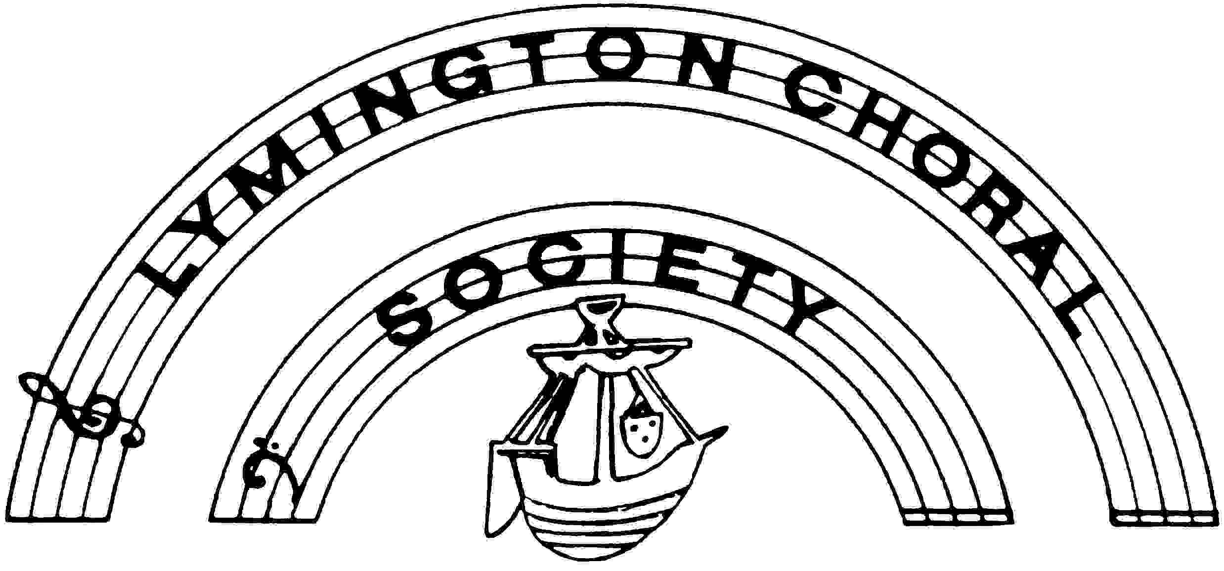

Affiliated to Making Music

Registered Charity No. 288724

Minutes of Committee Meeting in the Redvers Room, Lymington
13th September 2016 at 7.30pm

Present:
Shirley Hewitt (Chairman)
Sheila Hammond (Secretary)
Nichola Kirby (Treasurer)
Sue Rusling (Alto Rep)
Chris Hobby (Bass Rep)
Jill Hendey (Fundraising)
Viv Parsons (Publicity)
Ann Lewington (Associate Members)
Ann Blacklock (Librarian)
Michael Goldthorpe (Musical Director)

- Apologies: Apologies from Barry Kent, Tim Rice and Maureen Askin. Maureen will not be able
to attend meetings held on a Tuesday but is happy to be soprano rep.

Shirley said she was planning to close the meeting at 8.45pm as she has asked the Voting Committee members to stay for a further short confidential meeting.

The Agenda order was adjusted as Nichola had another event to go to.

- Treasurer's Report: The Accounts to be agreed and signed by Nichola and Shirley before going
to Roy Pattison. The examined Accounts would be available for the AGM.

We have just received the most recent GiftAid totalling £707.50. Nichola reminded the meeting that the previous year's large GiftAid total was several back payments. Nichola clarified for Viv the advertising income in the programmes and Viv was congratulated for her good work. Viv confirmed that she was within budget. Michael said that the rehearsal costs were higher due to the longer Spring term. The orchestral costs were higher but offset by lower soloists fees. Income from ticket sales and programmes had increased. The Society was in a good position due to fund-raising and donations. Viv had advised a possible grant source, the John Rayner Trust which Shirley will follow up. The search for a new Treasurer continues.

- Minutes of last meeting: Minutes of last meeting were agreed and signed.

- Matters arising: Feedback from concert: The Hall was not available at 5pm for the orchestra to use.
The TV screens were not working. Timing and placing of the banners, both on Quay Hill and Moore Blatch was discussed. Barry will be asked to liaise with Dave Parsons. There was a problem at the front desk with Priestlands parents/guardians coming and not expecting to pay. The Committee agreed by a majority vote that parents/guardians could come in for free if booked in advance (maximum 2 tickets). A letter would be given to the parents/guardians. Priestlands children to be thanked by giving them a token gesture eg sweets.

Viv asked if it was necessary to have the St John Ambulance at our concerts. Shirley said that in view of what had happened to several choir members at the Christmas concert she thought it was. They will arrive at 6.30pm and charge £100. The Committee agreed that it was necessary.

5. Chair Report (attached): Rules: Shirley said she hoped the Committee had had a chance to look at the rules and but gave them a bit longer to look at them. Any major changes would be confirmed and the rules distributed for people to see two weeks before the AGM (5th October). It was suggested that the wording of 'employee' be changed for 'Musical Director' and 'Accompanist'. The Committee would like to thank Shirley for all her hard work on the Rules.

Appointment of Trustees: The new Constitution was adopted by the members at the Special General Meeting on 18th November 2015 and authorised by the Charity Commission on 9th March 2016. Under the new Constitution the Committee in place at the time of adoption are the first Trustees. At each AGM a third of committee members shall retire and be eligible for re-election up to a fixed number of three year terms as set out in the Society's Rules and Regulations, 2 terms ie total 6 years suggested.

As this was the first opportunity for election of Trustees since the adoption of the Constitution, Shirley suggested that the whole Committee is nominated and elected, then next year we can start the process of 3 or 4 of us retiring and being re-elected for the three year periods.

The current Trustees identified by the Charity Commission under our old Constitution are the Chair, Treasurer, Secretary who are the Officers and the 4 voice reps. The other Trustees could be, should they wish, Ann (Associate Members), Jill (Fundraising/Archivist, Viv (Publicity and Ann (Librarian) and they all agreed. Shirley told the Committee that all Trustees are legally accountable for all Society matters.

Shirley hoped that within the three year appointment process we can retain continuity and a balance of experience on the Committee. How this will work in practice will depend on how long members wish to be on the Committee and whether we find new Committee Members.

If there are any Committee changes during the year, the Constitution allows for co-opting Trustees in between AGM's.

6. Musical Director's Report (attached): Michael suggested a Choral Day possibly in March 2017, possibly to sing Vivaldi 'Gloria'. He had also been in touch with the Director of St Barbe Museum and Lymington Town Band Director regarding the Choir singing at the official re-opening in June 2017. Both these occasions will be mentioned at the AGM.

The first rehearsal went well, we had 2 new ladies and hope the new bass comes. Frank and Jill Gregory will not be coming this term. Shirley would check on members who did not come to the first rehearsal.

7. Any Other Reports:

Associate Members: Ann had nothing to report. She would soon be sending out letters to Associate Members and Patrons with the bookmark. With input from Viv the letter will invite them to become more involved with the concert and publicity etc..

Publicity (report attached): Viv had liaised with Michael to reduce the recordings on the website which were taking up space in view of the extra cost being asked by New Forest Online. This has been done and costs have been kept down. Viv said she would not continue with the Caption Competition as the number of entries was low. Michael was asked for a design for the poster/banner.

Fundraising: Jill has not yet booked a date for the Quiz Night. She has booked the Church Hall on the 8th April for the sale. It was suggested we might repeat the Milford Lunch.

Michael left at 8.55pm.

The Committee then discussed Conductor and Accompanist fees. It was agreed unanimously to increase the Conductor's rehearsal fees to £45 per hour and his concert fee to £470, and the Accompanist fees to increase to £28 per hour. Both have now been informed.

Accounts: Chris Hobby proposed to accept the Accounts, seconded by Sue Rusling. This was carried and Shirley and Nichola signed them.

Next Committee Meeting: 17th January 2017 in the Redvers Room.

Meeting finished at 9.15pm

