LYMINGTON CHORAL SOCIETY WEBSITE INFORMATION
The website’s purpose is to publicise the Society to the general public and to share music and other information with LCS members.
It can be found by typing either Lymington Choral Society or www.lymingtonchoral.org.uk in a computer Search Engine, e.g. Yahoo, Bing, Google, etc.
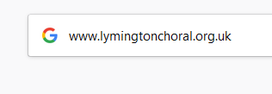
The website consists of five pages and to read them please click on menu, the dark blue tabs seen at the top of the Home Page, shown below. The contact number above the tabs is that of Karen Brett, the Society’s secretary.

THE PAGES IN DETAIL:
The Home Page
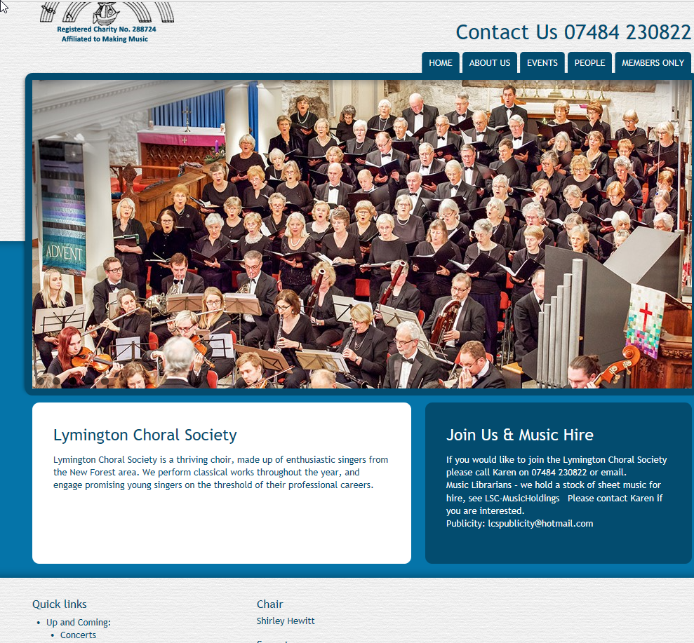

The Home Page appears when the website is first opened. The menu and telephone number shown to the right of the logo have been explained above. The photographs are images from the last concert whatever it might be, they move from photo to photo automatically in a slideshow. Beneath them to the left is a short description of the choir. On the right-hand side are contact details for the secretary, details of the choir’s music holdings (other choirs borrow LCS’ books) and for the Publicity Team. On this section when the computer mouse hovers over any link, it changes colour and when clicked directs you elsewhere, e.g. the words in white print ‘LCS-MusicHoldings’ change to a blue colour and take you through to the list of the music held by the choir.
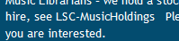
Using your mouse, or the down arrow on your keyboard, go to the bottom of the page where there are Quick links to all pages on the website. Clicking on any one of them takes you to a page. NB The links on the left are not underlined as normal but shown as bullet points.
To the right of the Quick links are details of the current officers of the choir and of the Musical Director and Accompanist, beside which are the names of the choir’s main photographer and the Company that hosts the website.
The About Us page
Using either a computer mouse or touchpad with the cursor on the About Us tab will reveal a drop-down menu showing six sections, About LCS; Our History; Performed Works; Soloists; Image Gallery; News & Newsletters. Click on any of those tabs or titles to show information. Alternatively click on ‘About LCS’ and continue to page down to read all. These sections are self-explanatory and are updated regularly particularly after concerts.
The Events page
This page is mainly for the general public, but choir members can use the page to remind them of various important dates. Click on the word Events and remember to page down to the bottom of the page to read all the information.

The People page
Nothing will open when the People tab is clicked. Like the About Us page this is another page with six sections; Patrons and Associates; Sponsors and Funders, Committee; Musical Director; Accompanist; Vacancies. Click on any tab or title to show information or click on ‘Patrons and Associate’s and continue to page down to read all. These sections are self-explanatory and are updated when personnel change.

The Members Page
This page is not for viewing by the general public. Click on the main tab on the Home page saying Members Only, type the password in the white box and click the word login which is on the right-hand side. The page will open with the words ‘Members only login’ appearing at the top.
(Please ask the Voice Rep. if you are unsure of the current password.)
This long page is divided into three main sections: Latest News; Practice Files; Useful Documents and Information. There is no ‘drop-down’ menu to access these sections, members need to start at the top and page down.
Latest News
Like all the sections on this page the items change regularly often week by week. Nearer a concert, the items can change almost daily. The news items are self-explanatory. Sometimes, a link will be given, e.g.
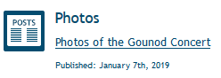
Click only on the underlined link words and a new page will pop up. In the case of the example above, when on your computer, click only on the words Photos of the Gounod Concert to view the photos. Nothing will happen if you click on the little icon saying Posts, if you click on the word Photos or on the date underneath, the underlined words are the links.
Practice Files
This is where the Musical Director has provided additional help for members to learn the music being sung currently in rehearsal, e.g. The Creation.
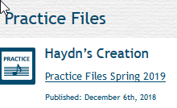
Click on the underlined words and a page will open displaying various movements, e.g. And the spirit of God. To the right you will see the words Tutti and the voice parts, Soprano, Alto, Tenor and Bass. Click on Tutti or your own voice part and the music will play.

IMPORTANT NOTE
If you do not hear the music, please ask a friend who has accessed the music or ask Viv P. There could be an issue on your own computer e.g. you do not have the appropriate software programme for sound.
Unless advised, members will NOT be required to pay for any of the music shown. Do NOT click buttons reading Start Download (Free) or similar.
From time to time we may be required to print our own music directly form the website’s Practice Files. Therefore, click on the link provided and you will find that a page of sheet music will open to allow you to do this. If you do not have a printer set up with your computer, please advise the Chair or Librarian who will arrange for you to receive a hard copy.
Other Practice File links will lead you to John’s Midi File Choral Music site. There will be a list of composers on the left-hand side beside which will be links to the pieces of music, e.g. see below.
Click on ‘As torrents in summer’, wait for a second and an electronic sounding piano will play the work enabling you to listen or sing along. As before, if you reach this point and are unable to continue please ask Viv Parsons for assistance. There could be an issue on your own computer e.g. you do not have the appropriate settings for sound.
Sometimes, practice file links will take you to a written page containing useful information.
Useful Documents and Information
This section usually contains links to various documents which will be of interest to members.
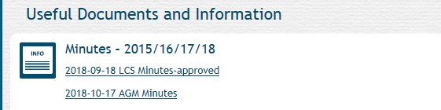
To remind you, links are the words that are underlined. Only click on the underlined words and a new page will pop up. In the picture above, for example, when on your computer, click on the words ‘2018-09-18 LCS Minutes- approved’ to read the Minutes from the Committee meeting held on the 18th September 2018.
The LCS Constitution and Rules also appear in this section.

